Grid Lost Fault

Author:Wesley
Reviewer:Eason

FAQ\Hybrid INV
Issue introduction
The error Grid Lost Fault on the inverter screen.
Confirmation of basic information
[Photo] SN numbers of inverters.
Guidance for installer
Step 1: Use a multimeter to measure the phase voltage and line voltage at the AC port.
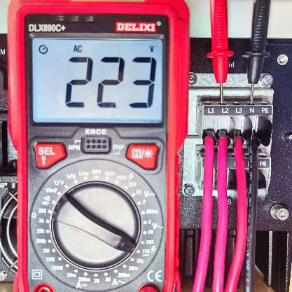 | 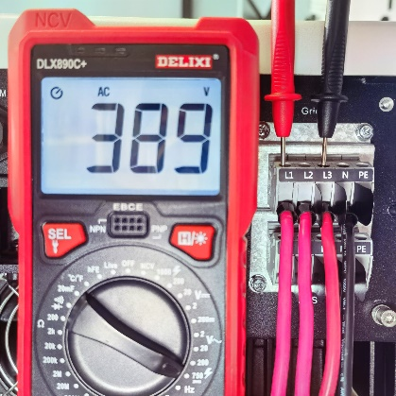
phase voltage | line voltage(line voltage＝$\sqrt{3}$×Phase voltage)
Ensure grid voltage is normal.
Step 2: Check the system status sampling information, which inverter displays on the screen. Ensure the detection of grid voltage in the inverter is normal.
Settings path: About → System status → On-grid
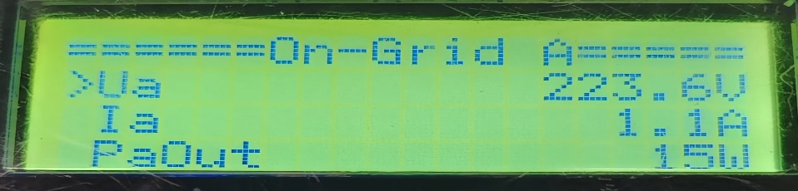
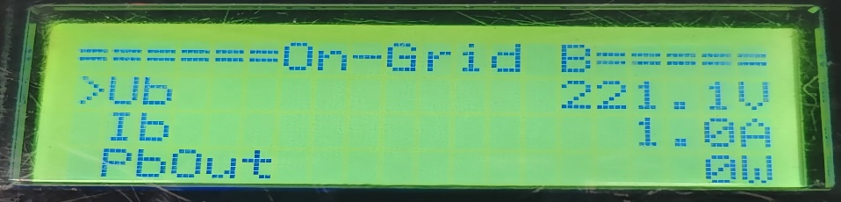
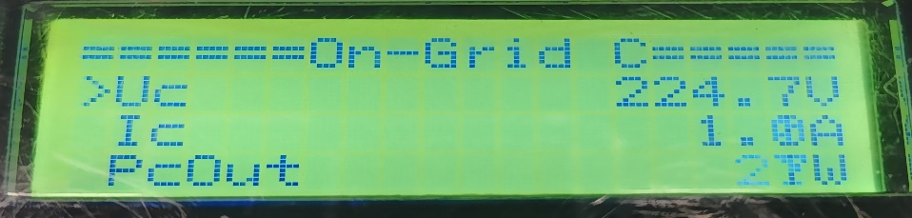
Step 3: Upgrade the firmware version to the latest and restart the inverter and check whether the inverter recovers.
Information check list
If you have completed the above <Guidance for installer>, and the problem is still not solved, please collect the following troubleshooting information and send them to the R&D.
- [Photo]SN numbers of the inverter.
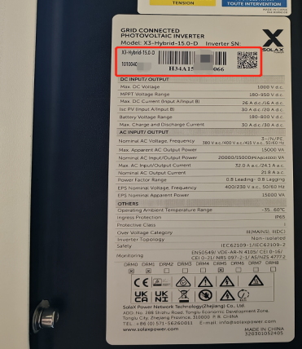
2.[Photo]Phase voltage and line voltage at AC side.
 | 
3.[Photo]On-grid voltage measured by inverter.




